Project Design Phase Solution Architecture

Date | 07/8/2026
Student Name | Livin Renith V L
Project Name | Shopez : E-Commerces Application
Maximum Marks | 4 Marks

Solution Architecture:
Solution architecture is a complex process – with many sub-processes – that bridges the gap between business problems and technology solutions. Its goals are to:
- Find the best tech solution to solve existing business problems.
- Describe the structure, characteristics, behavior, and other aspects of the software to project stakeholders.
- Define features, development phases, and solution requirements.
- Provide specifications according to which the solution is defined, managed, and delivered.

Shopez : E-Commerces Application – Solution Architecture Diagram:
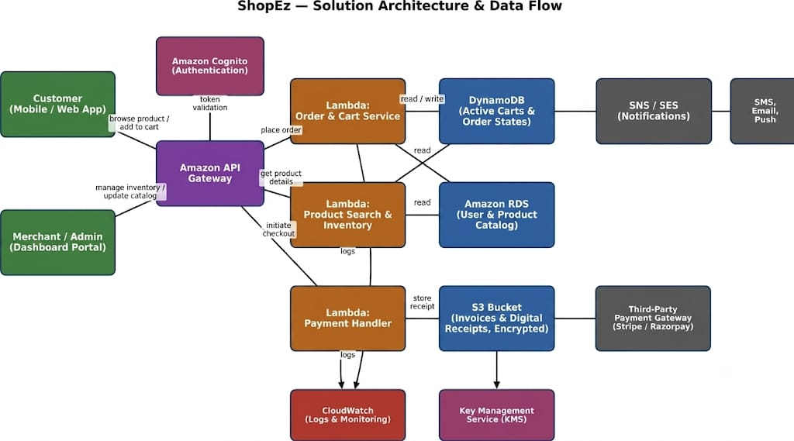
Figure 1: Architecture and data flow of the Shopez : E-Commerces application

Architecture Flow Description:
- Customers use the ShopEZ web application to browse products, search by category, add items to their cart, manage their wishlist, and securely place orders. Administrators use a dedicated dashboard to manage products, categories, orders, and users
- User requests are sent from the React frontend to the Node.js/Express backend through RESTful APIs, where authentication and authorization are validated using JWT before processing the request.
- The Authentication Service manages user registration, login, and profile updates, while the Product Service handles product listings, search, filtering, and inventory management. The Order Service processes orders, updates order status, and manages customer order history.
- Product details, user accounts, shopping carts, wishlists, and order information are securely stored in MongoDB, enabling efficient data retrieval and updates.
- Payment receipts and medical reports are stored in an encrypted S3 bucket, with encryption keys managed by KMS.
- The backend includes centralized error handling, request logging, and API monitoring to ensure application reliability, simplify debugging, and maintain optimal performance.

Reference:

Architecting a Highly Available Serverless, Microservices-Based Ecommerce Site | AWS Architecture Blog

